**SRE Project**

**Vision and Scope Document**

**Title: Platform for Smart Home**

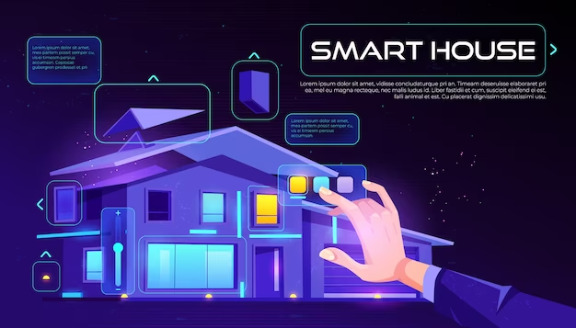**Project Contributors:**

*Abdullah Imran*



1. **Business Requirements:**

We want to develop our platform so that we can achieve our targeted business goals and requirements. These requirements directly impact on our business and they are discussed below:

**1.1: Business Background:**

A platform to build a smart home has been pretty popular around the world, although not in Pakistan. The market share to automate your home appliances (and more) is almost negligible when we see around us. And hence, the creative thinking of the group seeking to fulfill this gap in our market led us to work on this project.

**1.2: Business Opportunity**

The existing products in the market of Pakistan are almost none, but internationally, Google, Amazon, and Apple provide the platform for Smart Home appliances. We aim at capturing the similar interests of the customers via our platform. This product will be attractive in the market for its cheaper cost, efficient connectivity with the home appliances, and interactive and user friendly interface that can be used by all age groups.

**- For corporate systems:**

For corporate systems, this platform will be able to connect the corporate appliances seamlessly via the organization's central protected device, and as per the working hours of the organization, it will also be able to switch on or switch off the appliances as per the schedule given to it.

**- For commercial systems:**

Our product will be competing in all possible markets and scenarios involving the home appliances, such as a home that wants to control it's appliances via their smartphone, a business which wants to control their appliances of a specific area via their device, and the special organizations which want to control their appliances remotely as per their needs. The difference between the market smart home app is that it only targets the specific home, but this is also targeting the businesses.

**1.3: Business Objectives**

Our aim is to target the 60% of homes and businesses in the large cities of Pakistan and automate them and save the houses from any possible hazard that might cause from the malfunction of home appliances – fixing the two issues in one go.

**1.4: Success Metrics:**

We aim at capturing 20% of the homes in the large cities and 30% of the businesses in the first 2 years since our product is released. That would mean that in each quarter, we should be successful in attracting the 2.5% of the homes and 3.75% of the businesses to automate their appliances via our platform. Our second aim is to gain a revenue worth Rs 2.5M from the first quarter, with 1M increase in each quarter. This would mean that the revenue of the first year will be Rs 16M.

**1.5: Vision Statement**

For homes and businesses who need to automate their appliances, the **Intelligent Appliances** is a platform that provides a single point of access to the appliances on a single platform, providing control over them. Unlike the related products in the market, our product can automate the appliances of both homes and businesses at present location or remotely.

**1.6: Business Risks:**

The first and foremost difficulty in this business would be to attract the attention of the market and make them realize the potential benefits of this product. This is because the market such that of Pakistan which isn't technology oriented will not feel the need to shift on this product which is what can make our product almost go unaffected on the market and we would not reach the potential objectives of our project. The way to mitigate this would be to do marketing via social media and 1-1 marketing via emails.

During the phase of our development, there will be issues related to the timing of the release since not a lot of products like this are in the market. We plan to release the product by the end of 4 months but there's a possibility that this might be delayed. The way to mitigate this would be to use an agile approach and hire the team that has previously worked on such platforms to avoid delay.

**1.7: Business Assumptions and Dependencies:**

Stakeholders of the project assume that there will be a seamless connection between the platform and the appliances and that it can work with the majority of the devices. This means that we will have to register most of the most common devices of each category. This product will depend on those devices and how those devices respond back to the product. The devices from different manufacturers and different working methods must be able to respond to the product in the same exact way. The product will depend on the 3rd party suppliers and their registration with our product to be able to be compatible with most of the common appliances.

1. **Scope and Limitations:**

Following are the scope and limitations of our project:

**2.1: Major features:**

- Appliances Automation: Control your appliances via our platform

- Remote use: Can be used to control your home and business appliances remotely

- Appliance Scheduling: Appliances can be scheduled at specific times to be switched on and off automatically.

- Security: Without the authorization, the user won't be allowed to change the settings or control the appliances.

- Multi-processing: Although one request is processed at a time, you can do multiple request processes at the same time and the appliances will do the function in the sequence that the request was placed.

**2.2: Scope of initial Release**

- Appliances Automation

- Security

- Remote use

These features take lower cost than the other features, are easier to be worked on and are the most important features related to this project. They are easier to develop and take less cost when compared to the other features of the project.

**2.3: Scope of Subsequent Releases:**

A roadmap will be built to release the remaining features later:

- Appliance Scheduling: a half month after the initial release

- Security: a month after the initial release

- Multi processing: 40 days after the initial release

**2.4: Limitations and Exclusions:**

A stakeholder might expect the platform to work with all possible appliances but the platform can only work with the registered devices. Similarly, the platform can’t process the multiple requests at the same time and firstly, the first request would be processed before moving to the next one. Such as the lights will be turned on before the A/C.

1. **Business Context:**

**3.1: Stakeholder Profiles:**

The types of customers for **Intelligent Appliances** are: the customers that want to automate their homes by sitting in their homes or controlling their homes remotely, they will increase their productivity and would be able to control their appliances via smartphone; the customers who want to automate their businesses by automating their office spaces and scheduling that, controlling from a central device that can be in or outside the premises of the office, and they can reduce the electricity expenses and the labor that is required to turn the appliances on and off; the educational institutions that want to automate their appliances such as the lights and A/C is turned off after the class time ends, and they will also be able to reduce their electricity expenses and automate the manual tasks which would also save them labor; and so on.

The other kind of stakeholders of it would be the manufacturers of the appliances themselves who want to increase the customers by attracting them to smart appliances/electronics; the investors who want to invest in our project and so on, they will have a new growing market to explore and to invest in that previously did not exist, and so on.

A constraint in this regard would be that we would have to market our product smartly in a way that it attracts the potential customers and stakeholders as we are competing in a newer market.

**3.2: Project Priorities:**

**Constraints:** Staff is a limiting factor as we require experienced staff which can increase our cost.

* Cost: it is also our constraint since we want the cost to remain as low as possible as we are competing in a new market that is not as balanced yet.

**Driver:** Features are our main driver as these features are the ones for which we are working on to plan and execute our project.

**Degree of freedom:** Quality of our product can be adjusted as per the feature, but we don't really want to be extraordinary in quality as that would drive up the cost.

The Project Manager of the project will adjust the quality of the features, their release cycle and staff as per the required feature to address the cost issues and also make the features be achieved in an intended way.

**3.3: Deployment Considerations:**

During the initial phases, we aim to deploy the project in the intended market, preferably that is related to electronics and home appliances. We plan out to handle the infrastructure issues by testing the traffic flow of the product after each feature release, with it being improved until it's done and ready to be deployed.